RNTM 09-005/21

RNRMC REWARD AND RECOGNITION HOLIDAY BREAK – PARK DEAN RESORTS

Sponsor: WORN – WO1 C Steedman RN, Carl.Steedman147@mod.gov.uk

Liaison: 2SLWO – WO1 I Wilson RN, Wilson, Ian.Wilson550@mod.gov.uk

16 Feb 21

Aim

- The aim of this RNTM is to highlight the background, criteria and awarding of holiday breaks to Royal Navy personnel and their families provided through the RNRMC Reward and recognition scheme.

Introduction

- As part of the Senior Command Warrant Officers’ (SCWO) initiative to improve reward and recognition in the Royal Navy, this scheme run by the Royal Navy and Royal Marines Charity (RNRMC), in conjunction with Parkdean Resorts has been introduced.

The Award

- Eligibility. The opportunity to apply for the award is open to all ranks and rates, regular, reservist personnel and families, within the Royal Navy. Its aim is to recognise not only the Service Person but also their families for the extraordinary sacrifices and support they provide whilst their spouses/partners and loved ones are deployed around the globe. In addition, under this award it also aims to recognise families that may have gone or are going through difficult times and where time away may help.

- Due to the way the awards are given, travel to and from the areas cannot be met by public funds or by the company providing the break. It is also the reward recipient’s responsibility to book the appropriate travel insurance for the break.

- Award Criteria. The award will be in the form of a 7, 4 or 3 day break at one of 9 resort locations made available by Parkdean Resorts which can be found at Annex A.

a) They also have included access to the ‘Margot’ (Wheelchair Friendly Access (WFA) accommodation at Southview (Lincolnshire) for Easter (w/c 5 Apr & 12 Apr and Summer (w/c 28 Jun to 6 Sep). This award can be spread over a two-week period within the dates offered above.
b) All offers also include a 30% discount on food and beverage and free entertainment passes during the break.
- Selection Board. The Divisional Officer/Troop Commander / Naval Families Federation (NFF) or Royal Navy Family & People Support (RN FPS) representative are to complete Annex B and email it to NAVY-1SLCNSSeniorCommandWO@mod.gov.uk for assessment against our criteria for approval. It should detail the nominee, area of choice (from Annex A) along with a short 200-word précis of why this reward should be considered. Once the completed Annex B has been received, the SCWOs; Warrant Officer to the Royal Navy, Second Sea Lord’s Warrant Officer, Fleet Commander’s Warrant Officer, Royal Marines Corps RSM, and the DE&S Command Warrant Officer, working with the Head of Grants (HoG) RNRMC (to ensure the criteria have been met), will board the applications and all will vote except HoG who is responsible for grant oversight. All applications will be notified of the decision of this board by the RNRMC.

- Presentation. The presentation of the award will be by local commands in a form of a certificate signed by all the SCWOs. Parkdean Resorts breaks will be enabled via liaison with the RNRMC, where successful awardees will be contacted directly by Parkdean Resorts to facilitate the break.

Summary

8. These reward breaks are to recognise the commitment, dedication and sacrifice Royal Navy personnel and their families have made in protection of our nation over the years. We and RNRMC are grateful for the generosity of ParkDean Resorts in recognising this and for making these breaks available.

9. Further information regarding this award, can be gained from the SCWOs: NAVY-1SLCNSSeniorCommandWO@mod.gov.uk.

10. This RNTM is to be reviewed on 16 Feb 22.

Annex A to
RNTM 09-005/21
Dated 16 Feb 21

REGIONAL OPERATIONAL MAP
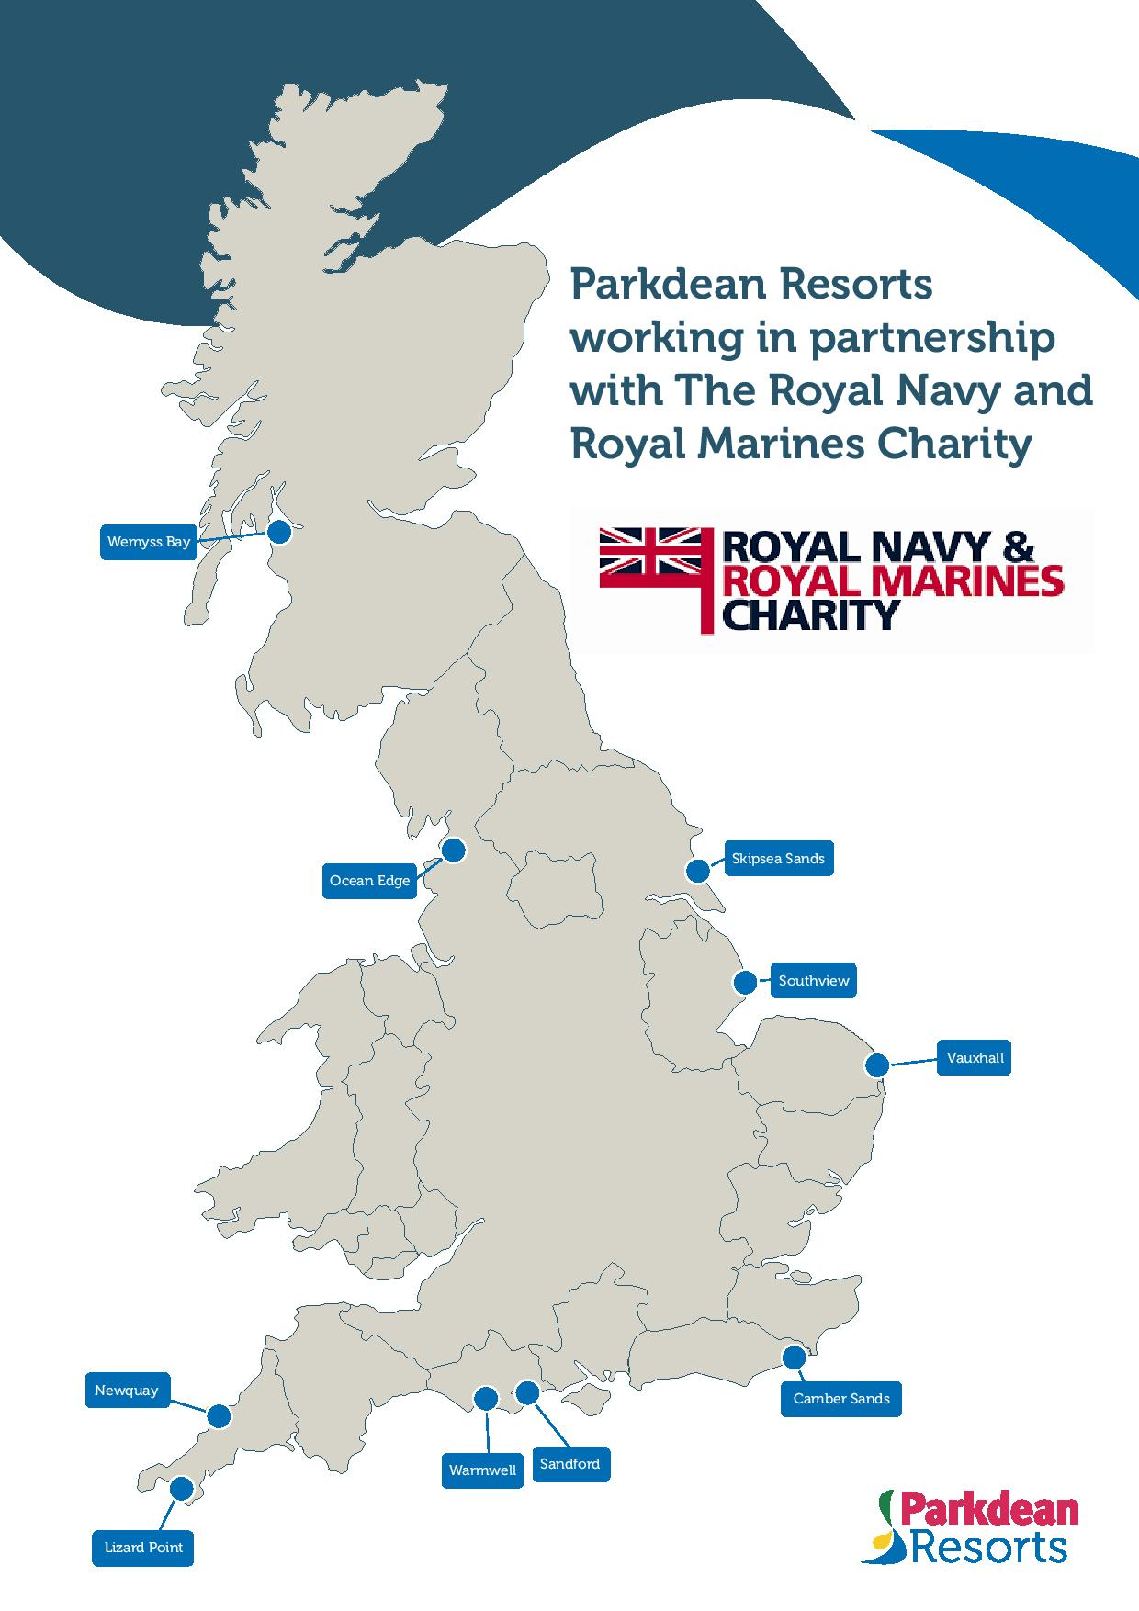

Annex B to
RNTM 09-005/21
Dated 16 Feb 21

RNRMC REWARD AND RECOGNITION HOLIDAY BREAKS

Date of Application

Name: |  | Rank/Rate: | Service Number:
Nominee Unit Address |  | Nominee Email Address | Nominee Contact details (please include no in family)
DO’s Name |  | DO’s Rank/Rate | DO’s Contact details
No Days preferred 7/4/3 |  | 7 Day – Check in Fri – Check out Fri  4 Day – Check in Mon – Check out Fri  3 Day – Check in Fri – Check out Mon
DO Signature

a. Reason for Nomination (200 words maximum). Break and preferred area requested.

Approved - Yes/ No

Royal Navy – Includes RN, RM, RFA and Maritime Reserves.
Parkdean Resort’s usual Terms & Conditions apply (https://www.parkdeanresorts.co.uk/terms-and-conditions/and that Parkdean resorts will process the Shared Personal Data (booking details such as name, address and contact details) in accordance with its privacy policy (which can be found at https://www.parkdeanresorts.co.uk/privacy-policy/.
While every attempt will be made to achieve the 1st choice, this cannot be guaranteed, and an alternative may be suggested.
This is further abbreviated as DO.

