



Appointment of Chair

Candidate Brief

December 2020

Reference: XAVJB

Welcome

**Dear Candidate,**

On behalf of the trustees, thank you for your interest in the Royal Navy and Royal Marines Charity (RNRMC), and in the appointment of a new Chair in particular.

We are looking for an outstanding individual to succeed Sir Bill Thomas when he completes his statutory term of office as our Chair. This is a wonderful opportunity for a top-calibre person to lead the Board through an exciting phase of the charity’s development.

With the encouragement and support of both the Royal Navy and Greenwich Hospital, the charity was formed in 2007 in response to the Admiralty Board’s vision for a single naval charity. The RNRMC collaborates and partners with organisations across the Royal Navy charity sector and is focused on honouring its vision: “A world in which our sailors, marines, and their families are valued and supported, for life.” We do so through a largely proactive programme of grant-making partnerships which seek to address the causes of need rather than just the symptoms.

In January 2020, the Board approved a five-year strategy for the period 2020-2025. The Board’s analysis was that the greatest impact for beneficiaries was achieved by a whole sector approach involving greater co-operation and collaboration between charities. Accordingly, the Board’s strategic objectives for the next five years are designed to help the Royal Navy family by identifying need and working with others to guide beneficiaries to appropriate support.

The Board is looking for an individual with the passion and the capacity to lead the charity to deliver these outcomes. As the single focus for naval charity, we have a substantial number of key stakeholders, ranging across Government, the Armed Forces, civil society and other charities. Critically, we are looking for a person with the credibility and skill to build effective and collaborative relationships.

Given the quality of our executive team in Portsmouth, and the commitment and generosity of our supporters and volunteers, the Board is confident that the RNRMC can continue to deliver on our promise to our beneficiaries, and we look forward enormously to a new Chair bringing their leadership skills to bear.

**Andrew Jameson OBE**

**Vice Chair of RNRMC**



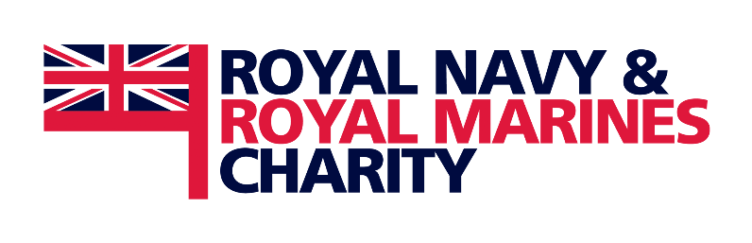

Introduction

The RNRMC’s charitable objects include the relief in need of serving personnel, veterans, and their families, as well as the promotion of efficiency within the Naval Service. The objects were drafted to reflect those of Greenwich Hospital so that the RNRMC could be used as a conduit for the substantial charitable assets of the Hospital.

**Our vision**

A world in which our sailors, marines, and their families are valued and supported, for life.

**Our strategic objectives 2020-2025**

* We will work with other charities operating in our sector to establish a confederation or alliance in order to provide those in need within our beneficiary group with a single point of access to the totality of state and charitable support available
* Acting with other naval charities and key stakeholders, we will ensure that our potential beneficiaries are made aware of the support that is available to those who need it
* We will collaborate with Greenwich Hospital with the objective of agreeing funding priorities to deliver our objectives
* We will commit to spending over 50% of our charitable expenditure on collaborative and long-term commissioning projects with other charities and organisations which seek to address underlying causes of need, whilst continuing to make other grants as the need arises
* Recognising the need to act decisively, we will undertake bold and far-reaching plans and projects with our partners that will draw down substantially on our total net assets as necessary

The role of Chair

The Chair is expected to carry out the duties of a trustee in accordance with the values of the charity. As Chair, the key functions of the role are:

1. Being willing and able to lead the organisation in partnership with the Chief Executive
2. Ensuring the charity has clear direction and is achieving its strategic objectives
3. Harnessing the skills, experience and energy of the Trustee Board
4. Ensuring key relationships are working so that the charity delivers on its objects
5. Overseeing the decision-making process of the Board to ensure sound decisions are made

Key responsibilities

**Leadership**

* Leading the governance of the organisation (but not its operations)
* Negotiating an appropriate balance between executive and non-executive
* Applying leadership judiciously and in good faith

**Strategic thinking**

* Ensuring the Board is clear about the purpose of the charity
* Ensuring that the Board focuses on identifying challenges and the strategy to overcome

them to meet its aims

* Ensuring that the organisation abides by a set of meaningful values

**Board cohesion**

* Maintaining a Board that includes a good range of skills and experience relevant to the work of the charity
* Investing time in the development of the Board as a team
* Creating a Board which is well positioned to manage strategic change and is willing to unite behind the decisions it makes

**Relationships**

* Building an effective relationship with the Executive team to get the best from them (including regular meetings with the CEO and a formal annual appraisal)
* Nurturing and developing certain key external relationships, notably with the Royal Navy, Ministers and others within the Ministry of Defence, and with the Chairs of other charities in the Group and the wider sector, especially Greenwich Hospital
* Working closely with our President and our honoraries

**Decision-making**

* Steering the Board in identifying key governance decisions to be made
* Making sure the Board makes good decisions based on evidence and sound reasoning, identifying risks and opportunities early
* Managing conflicts of interest and of loyalty to ensure probity is maintained

Person specification

**Experience**

* Experience of strategic senior leadership of a complex organisation, in any sector (public sector, private sector, civil society or Armed Forces)
* Successful track record of achievement through their career
* Experience of charity governance and working with or as part of a Board of Trustees
* Substantial experience of external representation, and especially the management and influencing of senior stakeholders across the public, private and third sectors

**Knowledge and skills**

* An appreciation for the military charity sector and the role it plays in the enhancement of military efficiency and morale
* Broad knowledge and understanding of the civil society sector and current issues affecting it
* Strong leadership skills, notably the ability to lead a Board to deliver on its vision and values
* Financial management expertise and a broad understanding of charity finance issues
* Good understanding of charity governance issues

**Personal Qualities**

* Demonstrate a strong and visible passion and commitment to the charity, its strategic objectives and cause
* Personal gravitas to lead a substantial national charity
* Exhibit strong inter-personal and relationship building abilities and be comfortable in an ambassadorial/influencing role
* Strong networking capabilities that can be utilised for the benefit of the charity
* Ability to foster and promote a collaborative Board environment
* Ability to commit time to conduct the role well, including travel and attending events out of office hours

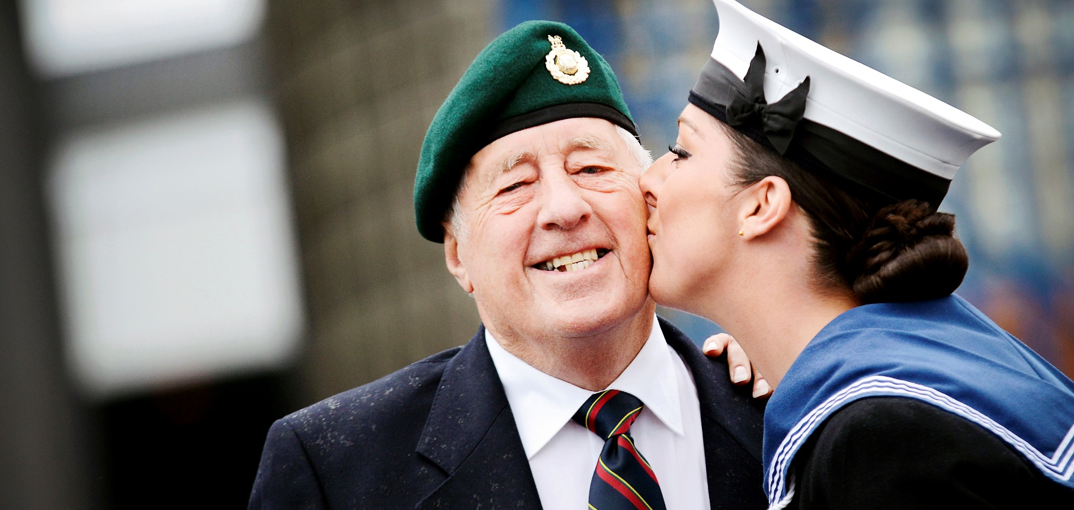

About Us

**Our Funding**

Our funding framework is a combination of grants **pathways** and funding **programmes**.

The two principal **pathways** seek to deliver key outcomes to serving personnel, dependants and veterans:

**Through Life Pathway**

We help throughout life and channel our funds to where need is identified at whatever stage. From elderly care, through mental health provision for children's charities, our outcomes demonstrate tangible differences whenever a safety net is needed. When the worst happens and a loved one dies while serving, we provide immediate and unquestioned financial assistance



**Quality of Life Pathway**

Focusing on our serving community we are putting our junior rates, other ranks and families at the top of our agenda. Our outcomes will be to show improvements to the lives of those in uniform and their families

Our funding **programmes** are focused on pre-emptive and proactive intervention, and often involve long-term and collaborative relationships with partner organisations and charities. Partners for 2021 include:

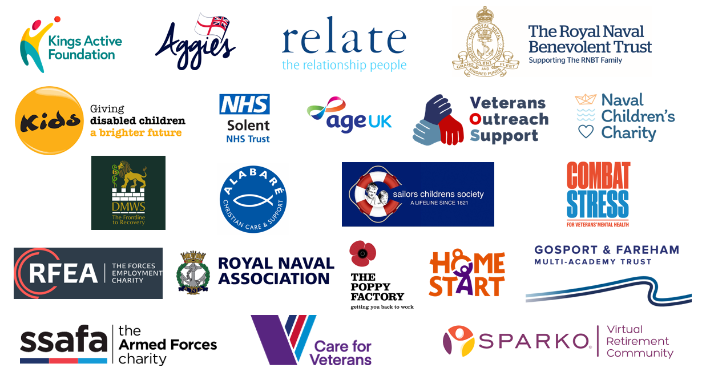

**Our Finances**

The RNRMC Group manages an investment portfolio of about £95m which combined with donations and grants received from individuals, charitable trusts and from Greenwich Hospital provides an annual income of over £10m. The Board has adopted a robust risk-based reserves policy which is allowing the Charity to drive down total net assets; and thereby use capital reserves to fund charitable activities. This has been hugely beneficial during the Covid-19 pandemic which saw an increase in demand for our support at the same time as a reduction in charitable donations. Use of reserves has allowed the charity to deliver its ambitious programme in 2020 (over £13m in charitable grants made).

Looking further ahead, capital reserves are not, of course, unlimited and so the charity will need to address the inevitable gap between need and resources. Opportunities exist through partnerships and through increased donations, and the next Chair will play an important role in shaping the strategy to overcome this fundraising challenge.

**Our Governance**

Our high calibre Board of Trustees (currently 15 persons) represents a blend of experiences and competencies and include those with Service experience and those with a wider background. They are selected through a formal interview process and appointed for an initial term of three years. Trustees serve a maximum term of three consecutive terms of three years.

The Board meets at least four times year and manages the business of the charity and exercises all powers of the company. In practice, the Board uses its power to delegate powers to committees, and the principal committees established by the Board are:

* Investment Committee
* Finance, Risk & Audit Committee
* Strategic Funding Committee
* Fundraising & Marketing Committee
* People Committee

The Charity employs a Chief Executive who is responsible for the charity’s administration and

financial management. The CEO works closely with the Board to develop the charity’s long-term

strategy, budget and business plan, and ensures the charity complies with the law and relevant

regulations. He also acts as an ambassador for the charity, building relationships with stakeholders,

and plays a key role motivating and engaging staff, volunteers, beneficiaries and donors. Our CEO Adrian Bell is supported by a senior leadership team comprising Chief Financial Officer, Director of Development, Director Relationships & Funding, and Director of Fundraising & Marketing.

Terms of appointment

The trustees are seeking to appoint a new Chair at their meeting on 20 April 2021, to assume responsibilities from 24 June 2021.

Trustees are appointed for an initial three-year term and can serve no more than three consecutive three-year terms. The Chair is appointed for an initial three-year term and is eligible for reappointment for one further term of three years.

The role of Chair typically requires:

* Nine days per year attending Board and other Committee meetings
* Six evening commitments per year in support of the charity
* Five hours per week of routine engagement

Trustees are not remunerated but are entitled to claim reasonable out-of-pocket expenses.

How to apply

Saxton Bampfylde Ltd is acting as an employment agency advisor to the Royal Navy and Royal Marines Charity on this appointment.

Candidates should apply for this role through our website at www.saxbam.com/appointments using code **XAVJB**.

If you have any queries or would like more information in regard to this appointment, please contact Sian Wild at Sian.Wild@saxbam.com or alternatively:

Aidan Kennedy

Partner

aidan.kennedy@saxbam.com

Rachel Hubbard

Partner

rachel.hubbard@saxbam.com

Click on the ‘apply’ button and follow the instructions to upload a CV and cover letter, and complete the online equal opportunities monitoring* form.

The closing date for applications is noon on **29 January 2021**.

* The equal opportunities monitoring online form will not be shared with anyone involved in assessing your application. Please complete as part of the application process.

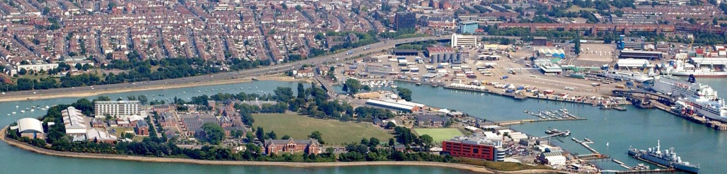



**LONDON**

9 Savoy Street

London WC2E 7EG

**EDINBURGH**

46 Melville Street

Edinburgh EH3 7HF

**saxbam.com**

Partners in **Panorama** - Search around the world

panoramasearch.com