Job title:  Marketing and Internal Communications Assistant | Hours:  Full Time 35 hours per week (Mon – Fri) | Responsible to:  Marketing and Communications Manager
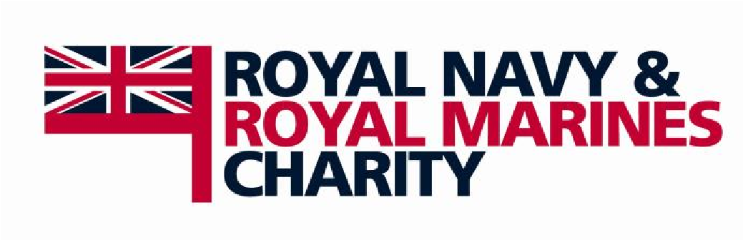
About the Royal Navy and Royal Marines Charity
The Royal Navy and Royal Marines Charity is the national charity of the Royal Navy. We recognise the demands placed on those who serve and their family members, as well as those who have served. It is the charity’s belief that while one person joins, the whole family serves.

Through grant awards given to ships and units who are deployed, post-service transition, family support and care in old age, the RNRMC is helping to create a world in which the sacrifice that our serving men and women have made is recognised no matter what. We provide a safety net for those who find themselves in immediate need; supporting counselling services, offering mental health provision and giving those who need the most basic of help, a roof over their heads and a hot meal.

We support all members of the Senior Service, all rates and ranks, full-time and reservist and their families from the day they join and for every day thereafter.

Role
The Marketing and Internal Communications Assistant will be instrumental in developing and supporting the internal communications strategy for the organisation.

In addition, they will provide high-quality administrative, marketing and general business support to the Marketing and Communications department in all relevant activities and duties, as well as provide administrative support to the Director of Marketing and Communications as directed.

The role holder must be able to fit into a small but busy and growing team where the tasks require enthusiasm and excellent organisational skills.

Responsibilities

General:
- Undertake daily administrative tasks to ensure the functionality and coordination of the department’s activities.
- Support the department in the planning and coordination of various projects, campaigns and events.
- Undertake tasks and activities related to grants communications, fundraising communications and other communications areas.
- Assist with composing and posting online content on the charity’s website and social media accounts.
- Assist in the organisation of traditional or digital campaigns and attend them to facilitate their success.
- Manage and update the database(s), including Raiser’s Edge NXT, in relation to any marketing and communication activities.
- Responsible for long-view document and other planning documents used by department.
- Support meetings relevant to fundraising and communications including scheduling, circulating papers and minute-taking.
- Compile and send out information and materials on behalf of the department.
- Fulfil postage requirements both internally and externally using Royal Mail and Parcelforce.
- Monitor the Communications mailbox and phoneline, responding to enquires and directing to the relevant member of the team.
- Prepare and deliver presentations and reports, as and when required.
- Undertake various office and other general administrative tasks as required.

Internal Communications:
- Develop a centralised platform for internal communications supported by enthusiastic champions around the organisation.
- Assist in the preparation, roll out, and delivery of accurate and engaging internal content.
- Conduct a full inventory and cleanse of the existing internal communications platform(s) (working closely with Operations department).
- Provide ongoing maintenance and development of internal communications platform(s), ensuring data/content is current and accurate.
- Create and curate new content and completing uploads.
- Provide advice and support to other internal communications platform(s) users, including coordinating and conducting inductions as and when required.
- Maintain the internal communications mailbox and responding to enquiries.
- Develop a regular internal newsletter or similar to distribute to staff, trustees, volunteers and other internal stakeholders.

Knowledge and Experience

Essential:
- Proven experience as a marketing assistant
- Experience of undertaking administrative tasks.
- Excellent written and verbal communication skills as well as the ability to change the tone of voice depending on the audience.
- Ability to liaise with different people from different teams every day of the week Strong prioritisation, time-management and organisational skills.
- Proven IT skills with Office 365 with particular focus/detailed usage of Microsoft Outlook,
Word, Teams, PowerPoint, SharePoint and Excel.
- Excellent knowledge of marketing computer software and online applications (CRM tools, Online analytics, Google AdWords etc).
- Understanding and empathy with the aims of the RNRMC.
- Evidence of a high work rate and effective productivity as the role requires working within
- tight timeframes.
- Ability to take Minutes or Records of Meetings.

Desirable:
- Experience of working in an internal communications environment.
- Experience of working for a charity or not-for-profit organisation.
- Understanding of HM Forces and the Services environment.

Education & Qualifications
- The role holder should be educated to GCSE or equivalent standard

Desirable:
• Degree or other qualification in a marketing or communications related field

Skills/Aptitudes:

Essential:
- Flexible and adaptable, able to juggle a range of different tasks to meet deadlines.
- Ability to remain positive and create a professional reputation for the RNRMC.
- Highly developed and effective interpersonal and communication skills.
- Possess an outgoing personality that allows you to build strong professional relationships with internal stakeholders
- Proven ability to be accountable and use initiative.
- Ability to work both alone and as part of a team.
- A willingness to learn new skills and working systems.
- Exceptional organisational skills.
- Ability to complete tasks within a structured work plan with minimal supervision and direction.
- Demonstrate a positive, willing and cheerful attitude and demeanour to ensure exceptional
- customer service is delivered.
- Commitment to high quality service and efficiency in all aspects of the organisation’s
- operations.
- Demonstrate empathy with the values of the RNRMC and must show potential and enthusiasm for increased responsibility as the charity grows.

